A Compact Inset Coupled-Fed Triangular Patch Antenna For Wideband 5G Applications

**\*Title:** A Compact Inset Coupled-Fed Triangular Patch Antenna For Wideband 5G Applications

**\*Field of Invention:** Fifth Generation Applications

**\*Objective of Invention:** The objective of the invention is a novel compact inset coupled-fed triangular patch antenna for wideband 5G applications

**\* Summary of Invention:** The invention presented here is an innovative approach aimed at a new compact octagonal shaped complementary split ring resonator with enhanced bandwidth. With the fastest development of modern wireless communication technologies operating over a wide range of frequencies, the new 5G radio access networks are expected to simultaneously support the number of connections. To enable 5G, FCC has divided the main spectrum into low bandwidth (upto 1GHz), medium band (below 6GHz), and high bandwidth (mmwave). The millimetre wave offers data rates over 2 Gbps and huge capacity, while low bandwidth offers good 5G coverage and medium band offers a combination of both. It is clearly desirable to use the 5G millimetre wave spectrum to achieve the goal of super-fast data rates. However, there are some critical challenges that need to be addressed before millimetre wave mobile communication can be implemented. In addition, the millimetre waves are prone to atmospheric attenuation and cannot propagate longer distances. On the other hand, the sub-6GHzwaves can propagate longer distances as compared to the millimetre waves and hence an afford able choice for long range, high data rate communication systems. The complementary split-ring resonator(CSRR) structure is achieved by etching SRR in the background, which can also realize resonance effect and has found great application in the design of wideband bandpass filter. The SRRs are very easy to introduce coupling in their resonant frequency, the synthesis method which was presented by Revy has been improved and some SRR bandpass filters have also been designed and fabricated.

**\* Detailed description of the invention:** Figure 1 shows the entire constructional geometry and structural features of the suggested antenna. Figure 2 shows the S-parameter value for the suggested Antenna structure.

With an improved VSWR value, the antenna operates across a larger 2.56 GHz bandwidth, from

2.67 GHz to 5.23 GHz. The strip that results in better miniaturization is situated at the radiating patch of the antenna. Broader operating bandwidth is accomplished by the inset coupling feeding mechanism. The SMA connector's soldering effects could be the reason for the little variations. Although it is employed in the experiment, the impact of the cable connector is not taken into consideration in the simulated results.

This design clearly shows that most of the energy flows at the inset coupling feed at 4.8 GHz, while most of the energy is dispersed throughout the exterior region surrounding the rectangular strips in the triangular patch at 3.6 GHz. The antenna's wideband behaviour is too much of an outcome of the inset coupling feed arrangement. The suggested antenna is constructed and tested under these antenna parameters.

Also this antenna show that the measured results of the proposed antenna coincide with the simulated radiation patterns in both the E and H planes. This is so evident since the polarization plane and radiation patterns are the same across the working frequency band. The operating frequencies have a bidirectional configuration in the E-plane and a roughly omnidirectional configuration in the H-plane.

These values make it very evident that the H-plane pattern has a higher relative cross-polarization than the E-plane pattern. This phenomenon is mostly caused by strong horizontal components of the surface current and electric field. Because the horizontal part of the surface current causes cross- polarization and the vertical part is the primary source of radiation. The improved antenna's experimentally observed gain at broadside orientation, from 2.8 GHz to 5.6 GHz. Throughout the working bandwidth, the obtained antenna gains ranges between 1.0 and 2.9 dBi. The greatest average gain of 2.95 dBi is reached at 3.2 GHz, and it remains nearly constant throughout the operational frequency range.

# Drawings:



**Figure 1**

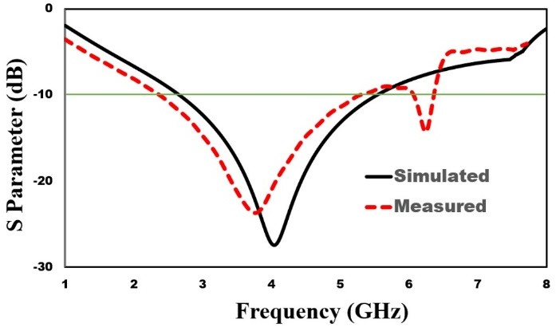

# Figure 2

* **Claims:**

1. An invention that employs a compact inset coupled-fed high bandwidth triangle antenna for Sub-GHz 5G applications.
2. As claimed in Claim 1, developed antenna includes combining the inset and coupling feeding with a triangle-shaped patch.
3. As claimed in Claim 1, it supports 5G applications at a frequency of 3.6 GHz.
4. As claimed in Claim 1, working frequency of 3.6 GHz spans the frequency range needed for 5G applications, which is between 2.8 and 5.6 GHz.
5. As claimed in Claim 1, total size just about 20.5 × 13.5 mm2.

# Abstract:

The invention presented here is an innovative for 5G applications, a compact inset coupled- fed high bandwidth triangle antenna is demonstrated. A large bandwidth can be achieved by combining the inset and coupling feeding with a triangle-shaped patch. With a VSWR of less than 2, the suggested antenna's working frequency of 3.6 GHz spans the frequency range needed for 5G applications, which is between 2.8 and 5.6 GHz. The primary characteristics of the suggested antenna are its smaller dimensions (20.5 × 13.5 mm2) and about 35% increased bandwidth. Significant factors that match the simulated results exactly are S11, radiation pattern, radiation efficiency, and peak gain in the proceeding of the proposed antenna. With the addition of two parallel rectangular strips with a triangular-shaped patch, the antenna is capable to achieve 40% reductions in size, 81.74% radiation efficiency, and 2.61 dB peak gain for the suggested antenna. With a center frequency of 3.6 GHz and a reflection coefficient of 28.6 dB, the fractional bandwidth is 66.67% (2.8 GHz to 5.6 GHz). With a smaller surface wave and an excellent omnidirectional radiation pattern, the antenna's inset coupling feeding arrangement makes it appropriate for Sub-GHz 5G applications.